**Name: Jean de Dieu UWINTWALI**

**EMAIL:** [**uwintwalijeandedieu3@gmail.com**](mailto:uwintwalijeandedieu3@gmail.com)

**Module: PLP Database**

**______________________________________________________________________________________________________________**

**Project name:** **MaternaCare**

**Project definition:** This project aims to develop a comprehensive maternal health monitoring system designed to assist healthcare providers in tracking pregnant women from the time of conception until childbirth. The system will focus on ensuring medication adherence to prevent complications such as premature births and infant mortality. It will consist of a centralized database that records essential information about pregnant women, their prescribed medications, and scheduled follow-ups. Healthcare providers will be able to use this system to send reminders, track patient progress, and intervene when necessary. By offering timely notifications and follow-up capabilities, the project seeks to improve maternal health outcomes and reduce risks associated with missed or delayed medications during pregnancy.

**SDG Selection:** SDG 3 aiming to improve maternal and fetal health.

**Problem Statement:**

Premature births and infant mortality are significant health challenges, often exacerbated by the failure of pregnant women to consistently take prescribed medications. Healthcare providers face difficulties in tracking and ensuring adherence to medication schedules throughout pregnancy, particularly in low-resource settings. Lack of timely follow-up and communication between doctors and pregnant women can lead to complications, including premature births or the death of infants. This project aims to develop a comprehensive follow-up system that allows healthcare providers to monitor pregnant women from the moment they are diagnosed with pregnancy until childbirth. The system will ensure regular reminders, track medication adherence, and enable timely interventions, ultimately reducing the risks of premature births and infant mortality associated with missed medications.

**ERD for my project**

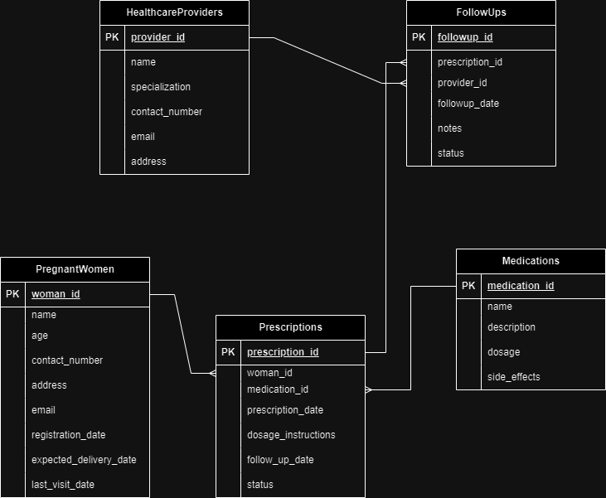

**SCHEMA FOR THE ABOVE ERD**

#### **Step 1: Define the Core Entities**

* **PregnantWomen**

**Description:** Represents each registered pregnant woman.

**Attributes:**

* + - woman_id (Primary Key, Integer, Auto-increment)
    - name (String, Not Null)
    - age (Integer, Not Null)
    - contact_number (String, Not Null, Unique)
    - address (String, Not Null)
    - email (String, Optional)
    - registration_date (Date, Not Null)
    - expected_delivery_date (Date, Not Null)
    - last_visit_date (Date, Optional)
* **Medications**

**Description:** Details the medications prescribed to pregnant women.

**Attributes:**

* + - medication_id (Primary Key, Integer, Auto-increment)
    - name (String, Not Null)
    - description (Text, Optional)
    - dosage (String, Not Null)
    - side_effects (Text, Optional)
* **Prescriptions**

**Description:** Links pregnant women to the medications prescribed to them.

**Attributes:**

* + - prescription_id (Primary Key, Integer, Auto-increment)
    - woman_id (Foreign Key, References PregnantWomen, Not Null)
    - medication_id (Foreign Key, References Medications, Not Null)
    - prescription_date (Date, Not Null)
    - dosage_instructions (String, Not Null)
    - follow_up_date (Date, Not Null)
    - status (Enum: Pending, Completed, Overdue, Not Null)
* **HealthcareProviders**

**Description:** Represents the healthcare providers responsible for prescribing and following up on the medication regimens.

**Attributes:**

* + - provider_id (Primary Key, Integer, Auto-increment)
    - name (String, Not Null)
    - specialization (String, Not Null)
    - contact_number (String, Not Null, Unique)
    - email (String, Optional)
    - address (String, Optional)
* **FollowUps**

**Description:** Records each follow-up interaction with pregnant women to ensure medication adherence.

**Attributes:**

* + - followup_id (Primary Key, Integer, Auto-increment)
    - prescription_id (Foreign Key, References Prescriptions, Not Null)
    - followup_date (Date, Not Null)
    - provider_id (Foreign Key, References HealthcareProviders, Not Null)
    - notes (Text, Optional)
    - status (Enum: Successful, Unsuccessful, Not Null)

#### **Step 2: Create an Entity-Relationship Diagram (ERD)**

An ERD visually represents the entities and their relationships:

1. **Relationships:**

**PregnantWomen to Prescriptions:** One-to-Many (One pregnant woman can have multiple prescriptions).

**Medications to Prescriptions:** One-to-Many (One medication can be prescribed in multiple prescriptions).

**Prescriptions to FollowUps:** One-to-Many (One prescription can have multiple follow-up entries).

**HealthcareProviders to FollowUps:** One-to-Many (One healthcare provider can perform multiple follow-ups).

1. **ERD Construction:**

Used draw.io to draw the entities and link them using the relationships defined above.

Clearly marked primary keys (PK) and foreign keys (FK).

#### **Step 3: SQL for Database Schema Creation**

1. **Create the PregnantWomen Table:**  
   CREATE TABLE PregnantWomen (

woman_id INT PRIMARY KEY AUTO_INCREMENT,

name VARCHAR(100) NOT NULL,

age INT NOT NULL,

contact_number VARCHAR(15) NOT NULL UNIQUE,

address VARCHAR(255) NOT NULL,

email VARCHAR(100),

registration_date DATE NOT NULL,

expected_delivery_date DATE NOT NULL,

last_visit_date DATE

);

1. **Create the Medications Table:**  
   CREATE TABLE Medications (

medication_id INT PRIMARY KEY AUTO_INCREMENT,

name VARCHAR(100) NOT NULL,

description TEXT,

dosage VARCHAR(50) NOT NULL,

side_effects TEXT

);

1. **Create the Prescriptions Table:**  
   CREATE TABLE Prescriptions (

prescription_id INT PRIMARY KEY AUTO_INCREMENT,

woman_id INT NOT NULL,

medication_id INT NOT NULL,

prescription_date DATE NOT NULL,

dosage_instructions VARCHAR(255) NOT NULL,

follow_up_date DATE NOT NULL,

status ENUM('Pending', 'Completed', 'Overdue') NOT NULL,

FOREIGN KEY (woman_id) REFERENCES PregnantWomen(woman_id),

FOREIGN KEY (medication_id) REFERENCES Medications(medication_id)

);

1. **Create the HealthcareProviders Table:**  
   CREATE TABLE HealthcareProviders (

provider_id INT PRIMARY KEY AUTO_INCREMENT,

name VARCHAR(100) NOT NULL,

specialization VARCHAR(100) NOT NULL,

contact_number VARCHAR(15) NOT NULL UNIQUE,

email VARCHAR(100),

address VARCHAR(255)

);

1. **Create the FollowUps Table:**  
   CREATE TABLE FollowUps (

followup_id INT PRIMARY KEY AUTO_INCREMENT,

prescription_id INT NOT NULL,

followup_date DATE NOT NULL,

provider_id INT NOT NULL,

notes TEXT,

status ENUM('Successful', 'Unsuccessful') NOT NULL,

FOREIGN KEY (prescription_id) REFERENCES Prescriptions(prescription_id),

FOREIGN KEY (provider_id) REFERENCES HealthcareProviders(provider_id)

);

#### **Step 4: Populate the Database with Sample**

**Insert Sample Data into PregnantWomen**

INSERT INTO PregnantWomen (name, age, contact_number, address, email, registration_date, expected_delivery_date)

VALUES (‘Alliace keza', 28, '1234567890', '123 Maple Street', 'Alliace.keza'@example.com', '2024-08-01', '2025-04-15');

1. **Insert Sample Data into Medications:**  
   INSERT INTO Medications (name, description, dosage, side_effects)

VALUES ('Prenatal Vitamins', 'Supplements essential vitamins', '1 tablet daily', 'Nausea, headache');

1. **Insert Sample Data into Prescriptions:**  
   INSERT INTO Prescriptions (woman_id, medication_id, prescription_date, dosage_instructions, follow_up_date, status)

VALUES (1, 1, '2024-08-02', 'Take 1 tablet daily', '2024-08-09', 'Pending');

1. **Insert Sample Data into HealthcareProviders:**  
   INSERT INTO HealthcareProviders (name, specialization, contact_number, email, address)

VALUES ('Dr. Emily Smith', 'Obstetrics & Gynecology', '0987654321', 'dr.smith@example.com', '456 Oak Avenue');

1. **Insert Sample Data into FollowUps:**  
   INSERT INTO FollowUps (prescription_id, followup_date, provider_id, notes, status)

VALUES (1, '2024-08-09', 1, 'Patient has been adhering to the medication regimen.', 'Successful');